Project 2 Proposal

Emmanuel Ayoo, Katie Buckner, Michelle Goodman, Polina Holland

For our Project 2, our group has decided to look at NFL statistics to look specifically for trends. By using charts, maps and graphs we are hoping to show player names, current team and position, where their hometown is and where they went to college, as well as their salary.

By doing this, we are hoping to give users the ability to easily see information such as where players most often come from, where the highest-paid players went to college, which positions have made the most money, and so on.

We will be using the data compiled from our ETL project, which can be found here:

<https://github.com/paholland/Project_Visualizations/tree/master/ETL_Project>

We will only be using data from the 2019 season.

There are a few visualizations that we will be using as inspiration as we complete the project. These will give us a few starting points as we begin to really dig into the information.

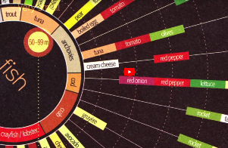 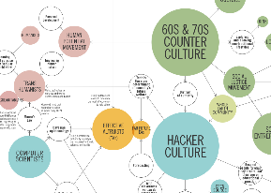 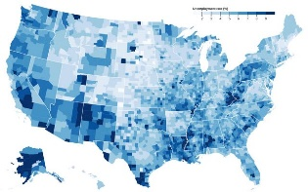 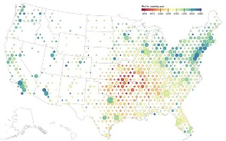

Using these as our guideposts, we would like to build a website whose homepage will display a dashboard with a navigation bar and with thumbnails of different maps and charts that they can look at. We want the following maps to be included:

* Where they are playing now
* Where their home state is
* Where they went to college

From these maps we want to be able to show data such as salary, name, position, etc. using layers and possibly a heat map.

We would also like to include a bubble or scatter plot to show salaries based on different variables chosen from a drop-down menu offering choices such as position played, hometown, and college.

Our Github repository found here:

<https://github.com/paholland/Project_Visualizations>

will have all of our data and the link to the Github page once we deploy it.